PEASLAKE PLAYERS

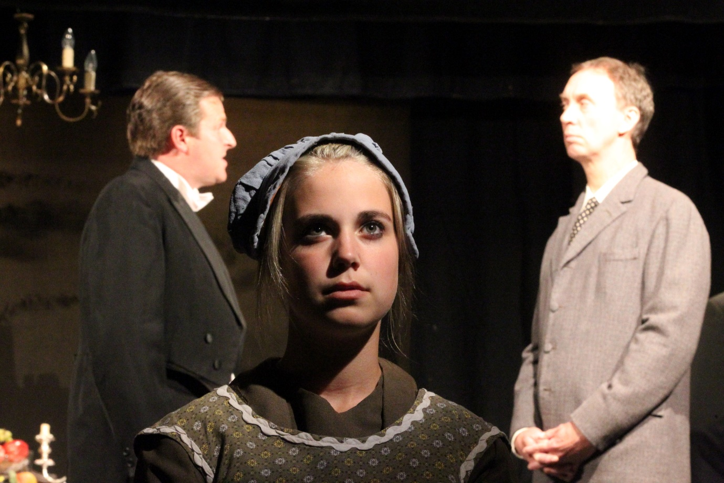

The Peaslake Players has been around for almost 70 years. We have a great base of talent around villages and towns around Peaslake, including Guildford and Dorking, but we are always looking for more.
We put on 3 performances per year, covering a wide range of genres, including dramas, musicals, comedy, tragedy, and including a spectacular pantomime every other year. Productions are usually staged at the Peaslake Memorial Hall.
We also have periodic productions performed by our junior members (7-12 year olds).
We send out monthly newsletters to our members keeping them in touch with future productions, social events, local courses and other items of interest.
We are very keen to have new members, whether to act or direct, or help with stage management, lighting, sound, or front-of-house! Please contact:
Ted Horton at peaslakeplayers@gmail.com
or fill in the contact form on the PP website: www.peaslakeplayers.co.uk/contact

